The Marjorie (Gigi) Strom
Memorial Scholarship Fund

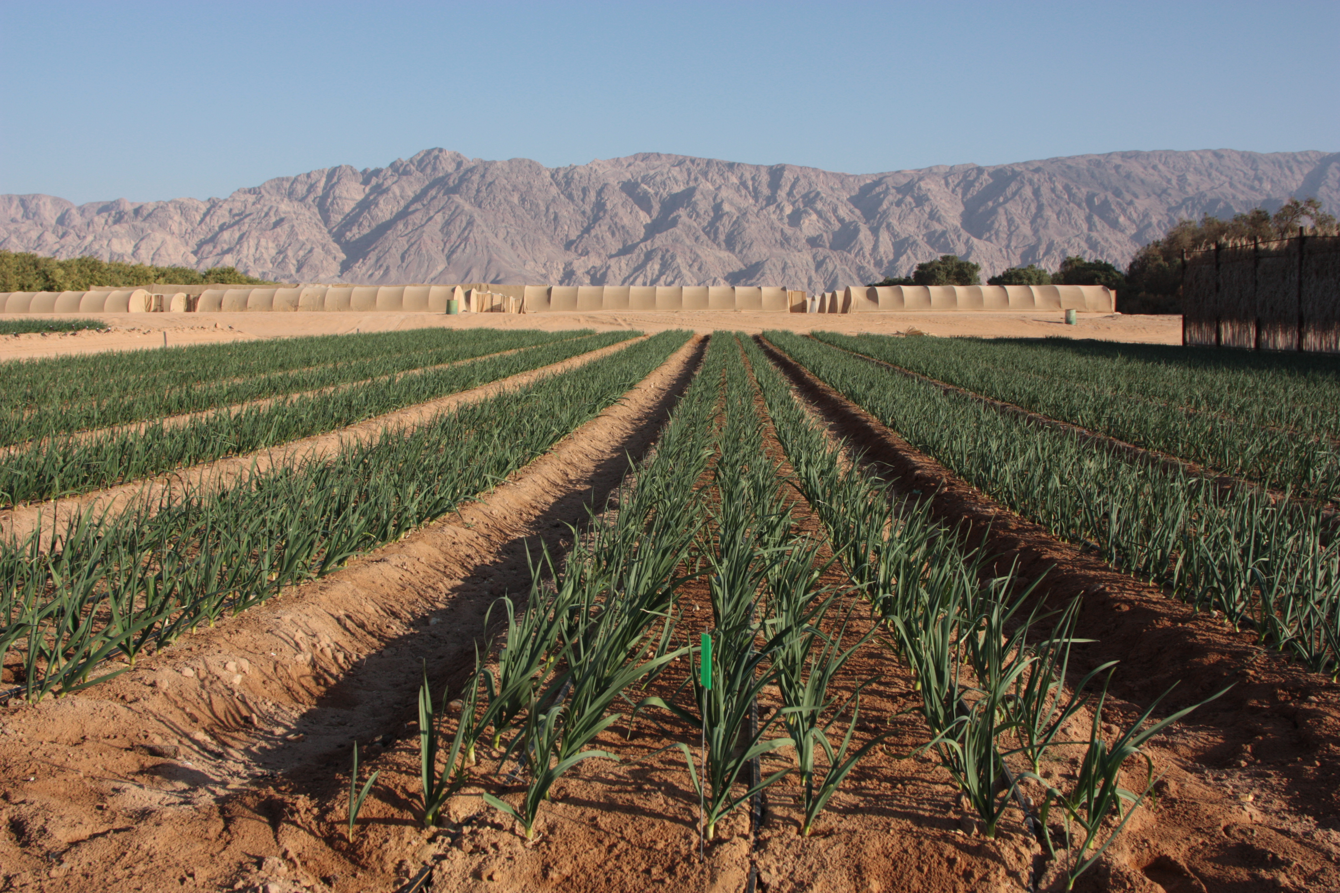

Marjorie (Gigi) Strom
1964-2015

Gigi was born in Brooklyn, New York in the United States. She chose her name herself since it was hard for her to say her birth name, and this independent streak continued throughout her life. After two years near Washington, DC as her father completed his Army service, the family settled in the city of Englewood in the northern part of New Jersey. Gigi was the third daughter in a family of four daughters. Her mother Joyce was a social worker and her father Leroy was a doctor; together they created a warm and loving home for the girls. Attending the city schools, a bat mitzvah trip to Israel and a summer at Kibbutz Gazit helped to form Gigi's Jewish identity. After completing high school Gigi went on to study psychology and literature at Cornell University, and even spent one semester studying in Jerusalem. During her studies Gigi's humanistic and pioneering nature found a home when she joined Reform Movement's Arava Garin. She was aided by her Hebrew studies and the guidance of Sandy Bem, a mentor for Gigi, who babysat her children from time to time.
When Gigi was a child she once asked her father if she could live on a farm, and received the reply "Jews don't do that!” Immigrating to Israel was just a matter of time, especially when she realized that she could live on a farm on which everyone is equal to the other and work together – in short, a kibbutz.
In 1987 Gigi made aliyah from New Jersey to Kibbutz Lotan. She worked on the kibbutz as a children's caregiver, as a maintenance woman and in the dairy farm, and finally as the kibbutz treasurer. During all those years there was always at least one dog following in her wake. In between jobs she gave birth to Yael and married Ofer. She came to Kibbutz Samar in 1997 and returned to her childhood love, working in the dairy. Following the birth of her children Yotam and Avshalom she worked as a comptroller and then continued on to kibbutz management. At the same time Gigi fulfilled various positions at the Dead Sea and Arava Science Center, where she handled research proposals, as well as working at the Hevel Eilot regional financial organization (Ardom). During this time, she studied for a master's degree in economics. She studied the dairy farms, collecting data from the farms, and helped to improve their efficiency through knowledge sharing.
And all of the time she also sewed quilts and baked the cakes that her family loved. This love was part of the greater love that she had for her family, both close and extended, which was also expressed by attending each big family event, and by her close attention to all the details of the lives of her family members, both in Israel and abroad.
Gigi's last job was that of the director of the Southern Arava Research and Development Station. As director she worked on enhancing applied research in the main agricultural fields of the region, including date orchards and field crops.

Throughout her life Gigi was engaged in the study of innovations that could help develop additional agricultural sources of income, and in the development of new directions for existing research at the regional agricultural R&D and the Science Center. The cooperation between local research institutions and the resulting mutual inspiration brought her great personal satisfaction. In her youth Gigi ran marathons, and the patience that she learned during long distance running helped her maintain long-term relationships between researchers from different countries, of different religions, with whom she shared study groups and good intentions.
Gigi's humanistic and socialistic outlook guided her throughout her life, leading her to work with many friends and various different entities in Israel and abroad in order to cooperate and share knowledge, and form simple friendships. This is her legacy.

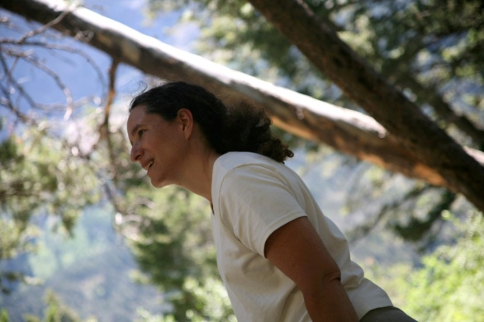

In Memory of Gigi Strom

Gigi,
It's been a year since you left us.
Time passes and life carries on, but we feel incomplete – talking together, consulting on issues big and small, personal, general and on the region as a whole.
You achieved so very much. I was privileged to work with you in many different ventures, at the Arava Institute for Environmental Studies, at the Dead Sea and Arava Science Center, on Kibbutz Samar, the agricultural R&D and as longtime neighbors.
We worked shoulder to shoulder in research, fundraising, team management and in liaising with the Council.
You came to the Southern Arava as a young girl full of faith, values and vision. Faith that we could build a young generation in agriculture, faith in doing our own work, complete faith in cooperation, and faith and boundless optimism regarding the ties with the neighbors in Jordan with whom we worked to build cross-border cooperation.
You decided to write your master's thesis on self-employment and hired workers, and you planned to write your doctrinal thesis on work and community in the Arava.
In all of the positions that you took upon yourself you always knew how to manage people, whether many or few. You knew how to lead with determination and sensitivity, and to inspire your partners with hope and faith.
On Samar, our kibbutz, you were able to find the right direction for the kibbutz from among the many varied opinions put forth.
You came to the R&D on the verge of a crisis, and you formulated strategy that perceived and defined the future needs of the region. You started by getting things moving and rehabilitating the R&D and building a program to fulfill the future needs of Hevel Eilot, properly utilizing the natural resources in this arid region that we call home. In addition to our natural resources we are also blessed with human resources, which need to be led wisely in the right way. You demanded much of yourself as well as from those around you. You collected information precisely and industriously and invested a great deal of effort in the consolidation of documents that presented and conveyed the necessary information simply and appropriately.
We want you to know that we are continuing on your path, both in the R&D and the Council. We are continuing our efforts to strengthen the young generation and self-employment in agriculture, and are supporting and building up our main fields of agriculture, the date orchards and the dairy farms.

The R&D is working on finding new young researchers who will take part in the promotion of agriculture using 21st century technology.
We miss you and are trying to fill the enormous gap that remained when you left us. We believe in a future in which we will achieve all of the goals that we set for ourselves, all in the spirit of the things you taught us during meetings, talks and working together.

Hanan Ginat, Head of the Hevel Eilot Regional Council

Gigi,
A year has gone since you left us, and I'd like to share some thoughts which come to me every time I think of you:
To me you symbolize optimism, determination, rationality, but most of all - faith in people and faith in the ability to effect change.
You took on the issue of generating joint reports from the dairy farms even though "each one has a different computer, they can't be compared and in general – “a dairy farm is agriculture, not science.”
You believed that people would pay attention to facts and data, and because they are basically good it's important to give them reports on their expenses and income, and they will behave accordingly, even though " are you thinking to draw up profit and loss accounts for each family? and particularly in Samar?"
You knew that together we could all pitch in and sort the fruit-bearing palms, not to mention your own work in the sorting shed.
We pulled together for the good of the future of agriculture in the Arava:
- You took charge of the column on smart agricultural know-how, which you decided to use for public relations for regional agriculture
- You believed in the development of the coming generation in agriculture and supported your belief both through the R&D and your own actions

One of the last projects that you led at the R&D was the launch of the collection of comparative information on the date orchards in the region – the field upon which we all depend. You managed to persuade all of the kibbutzim to join the project, even though "dates aren't science, everyone works differently, and in any case the data won't affect the behavior of the growers"; and just now, a month ago, we saw the outcome for the first time – thanks to you.
We saw the best of your optimistic nature and determination in the way you fought the disease that, sadly, overcame you.
People who want to bring about change and make an impact arouse resistance, because it's always easier to remain on the beaten track, rather than to start a struggle. Despite your determination to bring about change, you did it through cooperation and persuasion, always fighting for your beliefs in the best way possible.
I lost my partner for the way forward. You gave hope and inspiration to many of us, and we mourn your premature passing, but the ideas that you believed in continue to gain momentum and take root in our hearts.

Idit – Ardom Director

Aliza Mayo, Deputy Director, Arava Institute for Environmental Studies
Gigi saw science as a way to connect people and countries. Her activities were always guided by her strong faith and clear vision of the great potential for prosperity of the Arava region in many fields, such as energy and agriculture, science and academia. She herself was a link between the science and research centers in the region, to which she conveyed her vision.
Gigi brought her unique ability for non-judgmental situation analysis to every task and challenge, using a scientific approach. This talent contributed to the advancement of many subjects in the region, from analysis of data in the dairy farms and date orchards, to her role as scientific editor of research grants at the Arava Institute. Her clear thinking, diligence and attention to detail brought about much success in promoting the Institute's funding by entities in the European Union as well as by regional entities.
Moreover, thanks to her sharp thinking and her infinite patience, Gigi also excelled as a teacher in the Institute's research methodology course, as well as in supervision of independent student research conducted as part of the course.
Gigi's work at the Institute and as a colleague in the region gave us profound appreciation for a brilliant, lucid woman, with vision and leadership ability, who saw the entire forest while at the same time giving personal attention to every branch and tree.
But in addition to the professional aspects of work, we, the staff of the Institute, remember especially the friendly talks we had over a cup of coffee, how she sewed parts of her beautiful patchwork quilts during meetings, her boundless love and pride in her children, her commitment to the community - her home on Kibbutz Samar, her uncompromising faith in Excel's ability to solve any problem that might arise, and, of course, her wonderful home-baked bread.
As the end of the first year since her passing approaches, we at the Arava Institute remember Gigi with love and longing, on both the personal and professional levels.

May her memory be a blessing.

The Thai Revolution
Analysis of the economic changes in the Arava region during the 90s
Majorie (Gigi) Strom (2002)

Imagine an isolated area on the outskirts of the country, divided ideologically into two separate regions, but which relies on the same economic resources. Sounds like an economist's dream for examining processes.
This is how Gigi began her analysis of the transition processes that took place at kibbutzim and moshavim in our region in the 1990s. Indeed, this is an exact and almost poetic definition of the situation in the Arava region. It is also a researcher's definition, one which reflects Gigi's general point of view; Gigi examined every point in her life from the political, social and economic ideological aspects, and she preferred this perspective to her private and personal point of view.
The article, written as a master's thesis, contains economic insights on the constraints of kibbutzim and moshavim, and helps them understand the economic choices made in each of the individual settlements and in all of them together, by explaining the economic results vis-à-vis the social situation and regional ideology. The conclusion is that given the ideological data, the two regions each chose a different economic alternative that maximizes the economic capabilities of each type of organizational system, and explains the existing situation in light of these understandings.
In accordance with the economic shifts and changes in the policy of the government and the Jewish Agency, the kibbutzim chose to maximize the economic efficiency of the worker by using mechanized crops and relying on crops in open fields, which allowed a small number of professional farmers to work a larger area and to use the water at their disposal. In contrast, the moshavim chose to develop labor-intensive agriculture in greenhouses and relied on Thai workers to expand agriculture and its profitability. This choice allowed the moshavim, whose members grew up on kibbutzim and came to the area in order to be professional farmers, to maximize the harvest and the quality of water available to them.

During the next few years the government continued to encourage farmers to employ cheap foreign workers and the kibbutzim also began employing Thai workers. The kibbutzim were divided into a group that decided to use foreign workers as much as possible, thereby increasing the cultivated area and the variety of crops grown, and a group which chose to focus on one or two crops. Gradually almost all of the growers stopped working on open fields, almost entirely. Today, the kibbutzim in the Arava farm very few open field crops, and most of them concentrate on date orchards and solar energy, greatly reducing the need for large numbers of workers.
The long amount of time that has elapsed since the end of the research and the intervening changes in the policies of the government and the settlement organizations require new studies to examine, for example, how government policy is causing the region to focus on a specific crop, thereby causing great economic risk to the entire region. Or what are the factors that could be changed in order to achieve greater diversity in the agricultural fields of the region, as well as various other interesting research questions.

The late Marjorie (Gigi) Strom Scholarships

The scholarship fund was set up in 2017 by Gigi's family in cooperation with the Southern Arava R&D and the Hevel Eilot regional Council, and was launched at the seminar held on Dec. 25, 2017, on the second anniversary of Gigi's passing.
The scholarship fund's goal:
Support, educate and promote the region's researchers and farmers

Criteria for receiving a scholarship:
- Relevant to the agriculture of the region – compulsory!
- Conducted in the region – compulsory!
- Supervision by a professional entity in the region – compulsory!
- Recommendation by a regional entity – compulsory!
- Arrival of a new researcher to the region – advantageous
- Offered up to age 40 – advantageous

Timetable:
- Publication of public tender – August
- Submission of requests to the fund – October
- Meeting of the committee to decide upon winning applicants – November
- Scholarship presentation ceremony - December

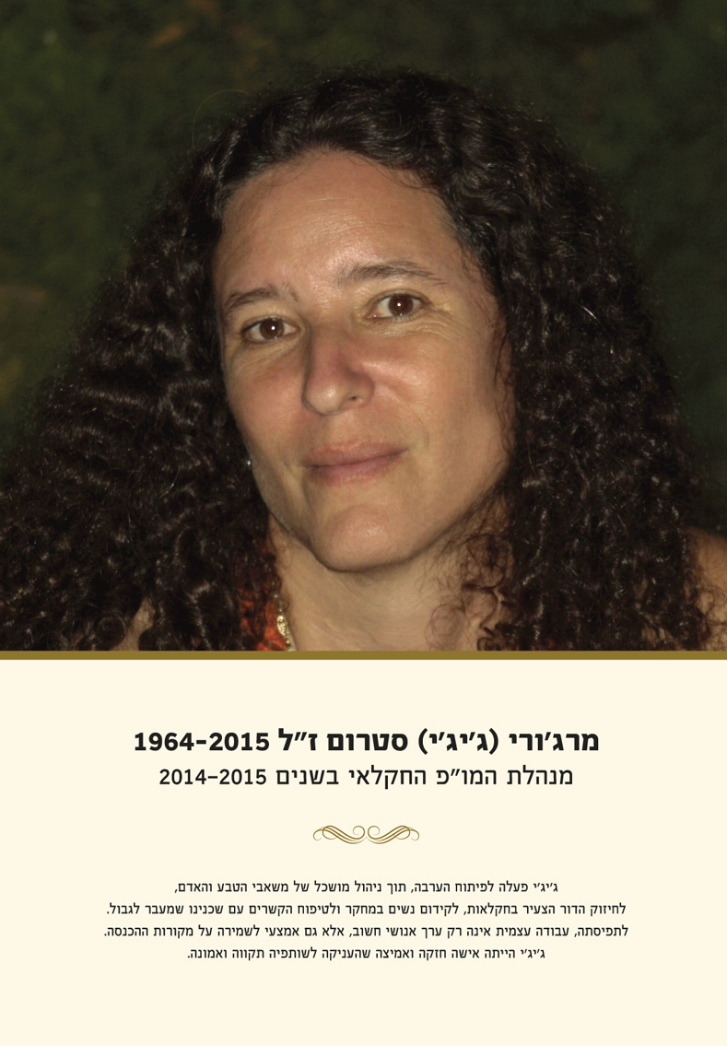

Options for Contribution to the Scholarship fund
- Donation of a NIS 10,000 scholarship
- Donation of a multi-year scholarship – the donor commits to funding a scholarship for a number of years in advance
- Donation to cover a year's activity of the fund - ILS 30,000-50,000
- Any other amount.

Each year the names of the donors will be mentioned at the ceremony for awarding the scholarships, to which the donors will be invited. Their names will appear on the Fund's website and will be mentioned in all fund publications for that year.

In the case of donation of a scholarship, this will be noted when the scholarship is awarded.

The donors will be given a report summarizing the fund's activities including the scholarship committee's reasons for the selection of the scholarship recipients.

No Overhead and No Management Fees
- The Fund is a limited foundation run by an association - the Renewable Energy Center.
- The Fund has income tax approval for donations according to item 46 of the Income Tax Ordinance.
- The Fund is run by committee of trustees led by
Ezra Ravins – Southern Research and Development Director

Among the members of the committee:
Dr. Hanan Ginat – Head of the Hevel Eilot Regional Council
Dr. Ilan Satvi – Director of the Southern Arava branch of the Dead Sea and Arava scientific R&D
Mr. Ofer Ben Tovim – representative of the family

- The Committee of Trustees publishes a public tender once a year.
- The Committee determines which of the candidates is eligible for a scholarship based on professional recommendations and fulfillment of the criteria.
- The scholarships are distributed in a ceremony.

The Marjorie (Gigi) Strom Memorial Scholarship Fund Thanks the Donors for Contributing to promotion of Research and Agriculture in the Arava

The Ben Tovim / Strom Family
The Hevel Eilot Regional Council
The Center for Renewable Energy

Public Tender December 2017
For submission of candidacy for scholarships to the Marjorie (Gigi) Strom Memorial Fund
- The Marjorie (Gigi) Memorial Fund will award scholarships to researchers and farmers in the Arava.
- The amount awarded for a single scholarship will be no more than
ILS 10,000.
- The scholarships are personal, for the scholarship recipients, and are intended to encourage researchers and farmers in agricultural activity.
- The Fund supports cooperation between research and agriculture on the settlements of the Arava.

The proposals should include:
- Curriculum vitae
- Information on the education and agricultural activities of the applicants in the Arava
During the judging process, the following criteria will be considered:
- Residence in the Arava
- Agricultural / research activity and the contribution to the region
- Research cooperation between the settlements

Applications should be sent by September 30, 2018 to:
Ezra Ravins – ezra@rd.ardom.co.il

